|  |
| --- |
| **Department of Health** |
| **Leah Van Kirk, Health Care Policy Advisor** |
| [leah.vankirk@alaska.gov](mailto:leah.vankirk@alaska.gov) |
| (907) 500-8407 |
|  |
| **Division of Health Care Services** |
| **Sarah Harlamert, Tribal Health Program Coordinator** |
| [sarah.harlamert@alaska.gov](mailto:sarah.harlamert@alaska.gov) |
| (907) 269-7398 |
|  |
| **Division of Behavioral Health** |
| **Jenn Carson, Division Operations Manager** |
| [jenn.carson@alaska.gov](mailto:jenn.carson@alaska.gov) |
| (907) 465-6271 |
|  |
| **Division of Public Assistance** |
| **Christina Davis, Chief of Policy & Program Development** |
| [christina.davis@alaska.gov](mailto:christina.davis@alaska.gov) |
| (907) 500-4746 |
|  |
| **Division of Senior and Disabilities Services** |
| **Tony Newman, Director** |
| [anthony.newman@alaska.gov](mailto:anthony.newman@alaska.gov) |
| (907) 465-5481 |
|  |
| **Division of Public Health** |
| **Lindsey Kato, Director** |
| [lindsey.kato@alaska.gov](mailto:lindsey.kato@alaska.gov) |
| (907) 744-6010 |

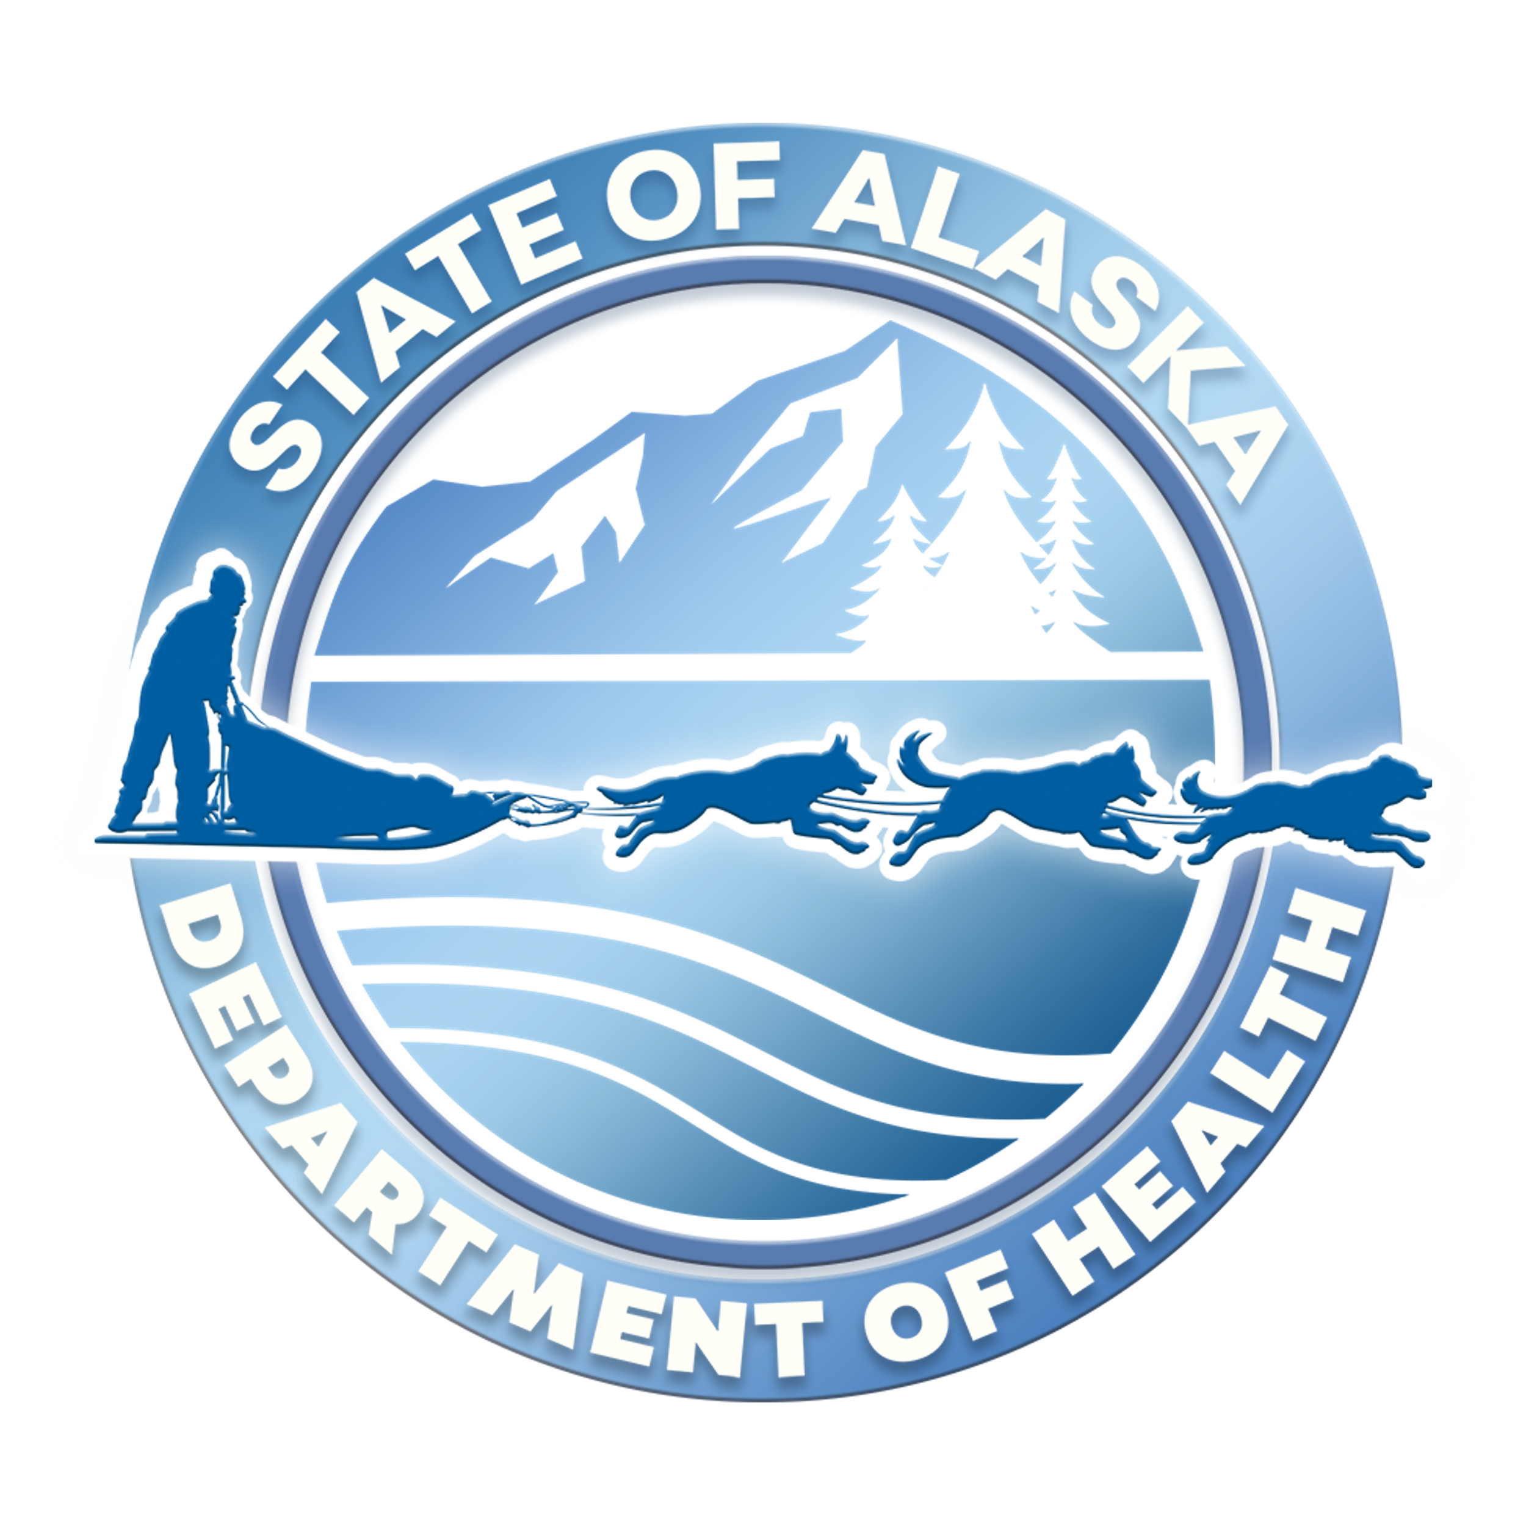

[Sidebar Title]

Department of Health   
Tribal Liaisons